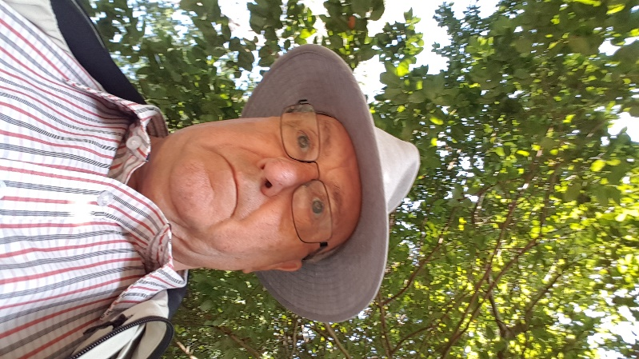
Colin’s Blog
Friday 8th February 2019
An appropriate look of bewilderment, as one tries to make sense of everything that is going on in our world.
The conflicts, the tragedies, injustices, and nonsense, which we all read or hear in the media, which, if taken literally, mean that we are living in troubled times.
The B word still dominates our National news, and, is regularly overshadowed by news about drugs and county lines, as well as the involvement of around ten thousand children and young people, snared into becoming involved in the unlawful practise of drug running, dealing and drug fuelled crime. It’s, a sorry state of affairs, which brings so much sadness to the families of those involved, and, escalates the opportunities for drug pushing and addiction. Knife crime which often results from such actions.
Cyber crime which blights the lives of so many people, especially our elderly and vulnerable members of our local communities.
Environmental crimes, that affect us all, and blight our countryside and urban areas. So much is down to greed and a general lack of respect, going back to the breakdown of moral behaviour, and often driven by poverty and fuelled by criminal behaviour.
Despite, the fact that I was born in the East End of London, I find so much of what is happening around us, totally alien to my way of life, and indeed, the way that I was brought up by my parents.
I am sure, that so much of today’s problems stem from the accessibility of social media, which is used and trawled by who I term as the younger generation. Instagram has been in the news recently over the suicide of a young girl who got ideas and information which led to her taking her own life. Other internet sites also contain such matter, and, sites like Facebook, can be platforms used to engage in bullying, as does the use of messaging and social apps on smartphones. You Tube also carries lots of what I term as dangerous channels of information.
In an effort to reduce risks, or control all the sites, our government are preparing to legislate to ensure that such material is taken off the web by those responsible for the sites. I reckon that they will have as great deal of difficulty in doing so.
Last week, I wrote about the importance of special schools, and I received a very good response from my remarks. One of my readers wrote to me about the benefit that their son has received from going to a special school at an early age. I wanted to reply to the email, but, sadly, it seems to have disappeared from my mailbox, so, if you are reading this, please get back in touch!
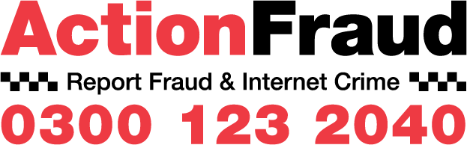 (Calls cost 35p per minute)

‘Inside The Mind Of A Scammer’ The Tactics Investment Fraudsters Use To Deceive Over 55’s’ Posted 7.2.2019
The Financial Conduct Authority (FCA) is urging over 55s to check investment opportunities are genuine before they part with their money. This comes as new research, commissioned as part of the FCA’s ScamSmart campaign, reveals that only two in five (42%) think they know how to spot a fraudulent investment opportunity. Fraudsters are targeting the growing over 55 population because they are more likely to have money to invest.
Only two in five think they know how to spot an investment scam
- Half of over 55s surveyed agree you need to act quickly to get a good deal, an attitude exploited by fraudsters who offer time-limited deals
- A third of over 55s surveyed are reluctant to discuss their investment decisions with others, something that is seized on by fraudsters who encourage them to keep their offer a secret
Last year, victims of investment fraud lost on average £32,000 as fraudsters employed increasingly advanced psychological tactics to persuade victims to invest. One of the most common methods used by fraudsters is to pressurise potential investors to make a quick decision on a time-limited investment offer. This new research found that more than half (53%) of the over 55s surveyed believed acting quickly can be key to getting a good deal, demonstrating how many could be vulnerable to this tactic.
A third (34%) said it is best not to discuss investment decisions with others and fewer than half (48%) said they would be likely to seek impartial advice before making an investment. These attitudes are seized on by fraudsters, who often urge their target to keep the offer a secret, in order to prevent others from dissuading them from investing.
45% of over 55s surveyed agreed that investment opportunities are more attractive if you know of others who have made similar investments. Fraudsters may exploit this by saying that others want in on the deal or have already benefitted.
Interestingly, those surveyed were more aware of certain signs of investment fraud, but less aware of others. For example, 92% agreed being contacted out of the blue could be a warning sign, but 19% were unaware that being promised returns above the market rate could also be a tactic.
The common tactics used by fraudsters include: -
- Unexpected contact – Traditionally scammers cold-call but contact can also come from online sources e.g. email or social media, post, word of mouth or even in person at a seminar or exhibition.
- Time pressure – They might offer you a bonus or discount if you invest before a set date or say the opportunity is only available for a short period.
- Social proof – They may share fake reviews and claim other clients have invested or want in on the deal.
- Unrealistic returns – Fraudsters often promise tempting returns that sound too good to be true, such as much better interest rates than elsewhere.
- False authority - Using convincing literature and websites, claiming to be regulated, speaking with authority on investment products.
- Flattery – Building a friendship with you to lull you into a false sense of security.
The FCA is urging consumers to be sceptical and cautious before they invest their money. If someone invests their money with an unauthorised firm then they will have no protection from the Financial Ombudsman Service or Financial Services Compensation Scheme if things go wrong.
To avoid being a victim of investment fraud, the FCA advises consumers to, at the very least: -
- Reject unsolicited contact about investments.
- Before investing, check the FCA Register to see if the firm or individual you are dealing with is authorised: https://register.fca.org.uk/ and check the FCA Warning List of firms to avoid: https://www.fca.org.uk/scamsmart/warning-list
- Consider getting impartial advice before investing.
Mark Steward, Director of Enforcement, FCA, comments: -
“Be alert to the warning signs like being contacted out of the blue, promises of low risk and/or guaranteed above market returns, special deals just for you, time pressure and, very often, flattery.
Be vigilant. Don’t let them push you into making a decision and parting with your money. Question their claims. Check the FCA Register and seek impartial advice. If in any doubt – don’t invest.”
Nick Hewer, who is supporting the campaign, added: -
“As someone who has been approached by scammers myself, I know how hard it is to identify whether an investment offer is legitimate. They’re very clever these people, playing psychological games to win over the trust of often vulnerable victims and that’s why I’m working with the FCA to raise awareness of this troubling issue.
“Remember, if it sounds too good to be true then it probably is. If you are offered an attractive investment out of the blue, be suspicious, check the FCA’s Warning List and seek impartial advice. Better still, if you get a cold call, just put the phone down!”
https://www.actionfraud.police.uk/reporting-fraud-and-cyber-crime
CARE DAY 15th February 2019
Care Day, the world’s biggest celebration of children and young people with care experience, is happening on the 15th February 2019. Care Day 2019 is an opportunity to celebrate the rights of care experienced children and young people and is a joint initiative between five children’s rights charities across the U.K. and Ireland, under the 5 Nations 1 Voice alliance. Become in England, EPIC in Ireland, VOYPIC in Northern Ireland, Voices from Care in Wales and Who Cares? Scotland. The alliance wants a world where the childhoods of these children and young people allow them to thrive and achieve their dreams so that they go onto have a future that is fulfilled, and they are proud of. Those who care for and support these children and young people are also asked to celebrate. It is also an opportunity to illustrate how care experienced people can feel different to others and why. So, this Care Day, everyone has the chance to get vocal, get social, or to get together in celebration of the care experienced community. Most of us are caring people whose care extends across our communities, embracing the needs of others, so I felt it was quite appropriate to bring this special awareness event to your attention. Our young people are the future of our country, and as such, need the support, encouragement and understanding of everyone who cares. Unfortunately, there are many children and young people who have not had the best start in life, and society has a duty to support them as they undertake the challenges that life puts before them.
Back to Nature
A Heron, watching me, watching him!
I thoroughly enjoyed the three Winter Watch programmes shown on the BBC recently, and, if the weather calms down a little, I look forward to many countryside and urban walks over the next few weeks, as I look for more signs of the approach of Spring!

DATA PROTECTION My blog is sent to members and supporters of Epping Forest, Brentwood and Harlow NhW groups. and partnership organisations. When you join neighbourhood Watch, you agree that your contact details are shared between Neighbourhood Watch and Essex Police under existing partnership agreements, and that they are not shared with other organisations or individuals. To unsubscribe from my blog, or from Neighbourhood Watch, please send an email to: -
colin@neighbourhoodmatters.org.uk quoting the area in which you reside, so that, I know from which to list remove your contact details. Thank you. Colin I. Freeman MITOL Trustee and Executive committee member of Essex County NhW Association, member of Epping Forest, Brentwood and Harlow
NhW committees and Advisor to London Community Watch. colin@neighbourhoodmatters.org.uk
