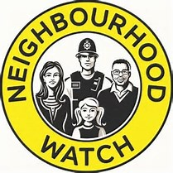

ESSEX COUNTY
NEIGHBOURHOOD WATCH
Gold Award Citation 2021
Names: Jeanette & Paul Henry
District: Tendring (Frinton)
Nominator: Colin Pendall

Jeanette has built her street watch up from one to four roads, and despite being infirmed, and having to use a mobility buggy, Jeanette, actively supported by her husband Paul, delivers NhW information to the members, many of whom are elderly, and do not have access to computers and smartphones, as well as producing a very informative newsletter, several times a year.

