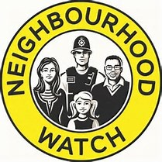

ESSEX COUNTY
NEIGHBOURHOOD WATCH
Platinum Award Citation 2021
Name: Steve Leverett
District: Chelmsford
Nominator: Norman Taylor

Steve volunteered to become secretary of the Chelmsford Group of Watches 10 years ago but, was elected Chair very shortly afterwards at the same time continuing to take on much of the secretarial work.
Steve is the driving force behind the thriving Group of NHWs in Chelmsford. His enthusiasm and drive inspire the local co-ordinators to work to improve their local watches. He is always keen to support new and established watches.
He is known as “Mr Neighbourhood Watch,” in and around Chelmsford, and richly deserves to be recognised for his work.

