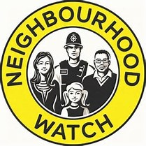

ESSEX COUNTY
NEIGHBOURHOOD WATCH
Citation 2021
Bronze Team Award
Name: Little Thurrock Rectory Ward Co-ordinators
District: Thurrock
Nominator: Marion Cherry

Desite these difficult times, the combined efforts of the co-ordinators, has maintained the community spirit that Neighbourhood Watch, has built up in the past few years, through WhatsApp, with regular updates about crime and community activity, as well as arranging activities to take place after lockdown eases. The team continues to offer assistance in the community where needed, and to litter pick in the local community garden.

